LAWLER ORB PENDANT
F31553

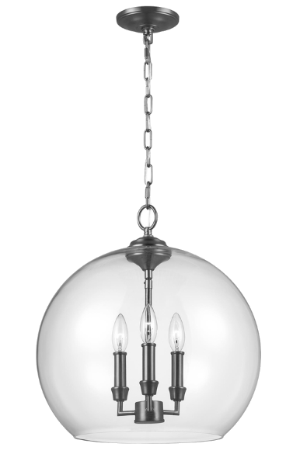

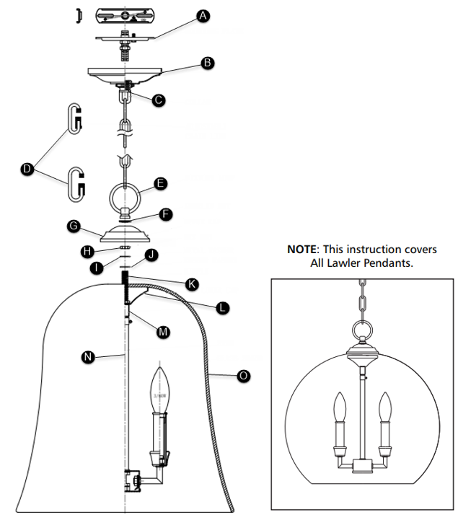
FIXTURE PARTS
- Mounting Plate
- Canopy
- Collar
- Adjustable Chain Link
- Fixture Loop
- Knurled Nut
- Upper Cap
- Hex Nut
- Metal Washer
- Rubber Washer
- Nipple
- Lower Cap
- Swivel
- Stem
- Glass Shade
INSTRUCTIONS
- Feed the fixtures wires through the stem and screw the stem to the socket assembly.
- Feed the fixture wires through the swivel and screw the swivel to the stem.
- Install the candle tubes by slipping them over the sockets.
- Install the candle followers by placing them on top of the candle tubes.
- Screw the lamps into the sockets. Refer to the label on the socket for Max Wattage information.
- Feed the fixture wires through the hex nut, metal washer, rubber washer and shade and then side them down onto the swivel and secure them together by screwing the hex nuts onto the swivel.
- Feed the fixture wires through the cup, knurled nut, and fixture loop, then slide them down onto the swivel and secure them in place by screwing the fixture loop onto the swivel.
- Follow enclosed supplement installation instructions for electrical and fixture installation onto house outlet box.

